**Testing Report:**

**Data Used:**

Manually created 500 sample data for the client with low credits or bad credits

**Predictions:**

To predict the interest rate of the customers.

**Model Used:**

Random Forrest

**Output:**

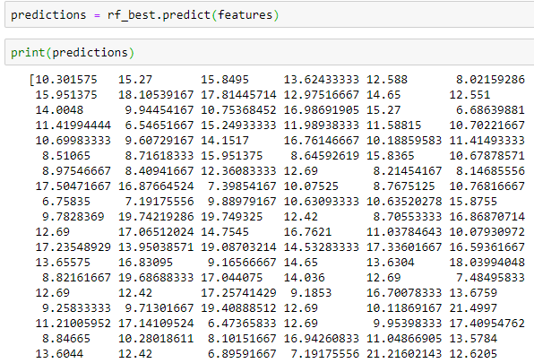

**Summary:**

Using our model, the client with low or bad credits can obtain the loan amount with certain interest rates. The interest rates can be little higher due to the grades he belong (E,F,G) and also consideration with respect to default rates.